Profile of the

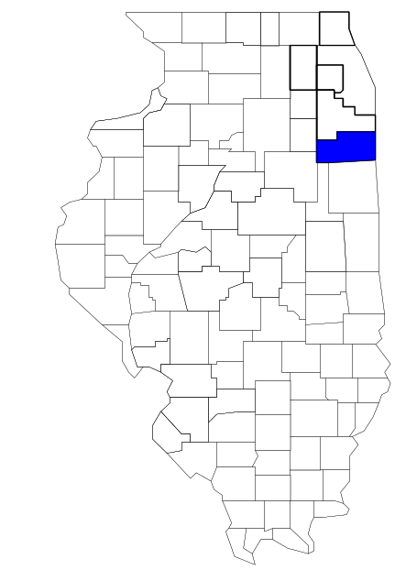Kankakee Area Metropolitan Enforcement Group

Prepared by

The Research and Analysis Unit of the
Illinois Criminal Justice Information Authority

George H. Ryan, Governor
Peter B. Bensinger, Chairman
Candice M. Kane, Executive Director

March 2001



ILLINOIS
CRIMINAL JUSTICE
INFORMATION AUTHORITY

This project was supported by Grant # 99-DB-BX-0017, awarded to the Illinois Criminal Justice Information Authority by the Bureau of Justice Assistance, Office of Justice Programs, U.S. Department of Justice. The Assistant Attorney General, Office of Justice Programs, coordinates the activities of the following programs, offices and bureaus: Bureau of Justice Assistance, Bureau of Justice Statistics, National Institute of Justice, Office of Juvenile Justice and Delinquency Prevention, and the Office for Victims of Crime. Points of view or opinions contained within this document are those of the authors and do not necessarily represent the official position or policies of the U.S. Department of Justice.

Illinois Criminal Justice Information Authority
120 S. Riverside Plaza, Suite 1016
Chicago, Illinois 60606-3997
Telephone (312) 793-8550
Telefax (312) 793-8422
TDD: (312) 793-4170
World Wide Website http://www.icjia.state.il.us
ACKNOWLEDGMENTS

A number of organizations and individuals put a great deal of effort into the development of this document. The Authority’s Research and Analysis Unit is very grateful for the assistance provided by the following organizations:

Administrative Office of the Illinois Courts
Illinois Department of Human Services’ Office of Alcoholism and Substance Abuse
Illinois Department of Children and Family Services
Illinois Department of Corrections
Illinois State Police
Kankakee Area Metropolitan Enforcement Group
U.S. Bureau of the Census

In addition, the following individuals were instrumental in gathering, interpreting and presenting these data:

Sharyn Adams

Megan Alderden

Robert Bauer

Alissa Clark

John Condne

Karen Griffiths

Tracy Hahn

Jennifer Hiselman

David Katz

Joseph Kozenczak

Gary Kupsak

Erica Morrow

David Olson

Adrianna Perez

Gerard Ramker

Robert Taylor

CONTENTS

Section Page Number

EXECUTIVE SUMMARY

I. Introduction 1
II. Trends in Violent Index Offenses and Arrests 3
III. Trends in Drug Arrests 6
IV. Trends in Drug Seizures 14
V. Trends in Prosecutions for Drug Offenses 16
VI. Trends in Percent of Convicted Drug Offenders Sentenced to Prison 18
VII. Trends in Drug Treatment Admissions in KAMEG Region by Drug Type 23
VIII. Trends in Drug Exposed Births 26
IX. Summary of Drug Situation 27
X. Appendices 30
Map 1 1999 Percent of Illinois' County-level Population Covered by an
Authority-funded Multi-jurisdictional Enforcement Group or Task Force 31
Map 2 1999 Illinois Cannabis Seizure Rates, by County 32
Map 3 1999 Illinois Controlled Substances Seizure Rates, by County 33
Map 4 1999 Illinois Methamphetamine Seizure Rates, by County 34
XI. Bibliography 35

LIST OF FIGURES

Figure Page Number

Figure 1. Violent Index Offense Rates for Participating and Non-participating Agencies in Region Covered by KAMEG 3
Figure 2. 1999 Violent Index Offenses* Reported by Participating and Non-participating Agencies in Region Covered by KAMEG 4
Figure 3. Violent Index Arrest Rates for Participating and Non-participating Agencies in Region Covered by KAMEG 5
Figure 4. 1999 Violent Index Arrests* Reported by Participating and Non-participating Agencies in Region Covered by KAMEG 5
Figure 5. Total Drug Arrest Rates for KAMEG and Participating and Non-participating Agencies in Region Covered by KAMEG 7
Figure 6. 1999 Drug Arrests* Reported by Participating and Non-participating Agencies in Region Covered by KAMEG 7
Figure 7. Total 1999 Drug Arrests* Reported by Participating and Non-participating Agencies in Region Covered by KAMEG, by Drug Type 8
Figure 8. Drug Arrests by KAMEG 9
Figure 9. Percent of Total Drug Arrests Accounted for by KAMEG 9
Figure 10. Cannabis Arrests Rates in the Region Covered by KAMEG as Reported by Participating Agencies, Non-participating Agencies and KAMEG 10
Figure 11. Percent of Cannabis Arrests Accounted for by KAMEG
11
Figure 12. Controlled Substances Arrest Rates in the Region Covered by KAMEG as Reported by Participating Agencies, Non-participating Agencies and KAMEG 12
Figure 13. Percent of Controlled Substances Arrests Accounted for by KAMEG 12
Figure 14. KAMEG Drug Arrests for Possession versus Delivery, by Drug Type 13
Figure 15. Cannabis Seized and Submitted to ISP by Kankakee County and Seized by KAMEG 14
Figure 16. Powder and Crack Cocaine Seized and Submitted to ISP by Kankakee County and Seized by KAMEG 15
Figure 17. Number of Felony Filings in Kankakee County 16
Figure 18. Total KAMEG Drug Arrests and Percentage of Arrests Resulting in Prosecution 17
Figure 19. Sentences Imposed on Felons Convicted in Kankakee County
18
Figure 20. Sentences Imposed on Convicted KAMEG Drug Offenders 19
Figure 21. Number of Drug Offenders Committed to IDOC by KAMEG and Region Covered by KAMEG 20
Figure 22. Drug Offenders as a Percent of Total IDOC Commitments from Kankakee County 21
Figure 23. Drug Offenders Committed to IDOC from Kankakee County, by Offense Class 22
Figure 24. Substance Abuse Treatment Admissions from Kankakee County 23
Figure 25. Comparison of Drug Arrests by KAMEG and Participating and Non-participating Agencies vs. Drug Abuse Treatment Admissions in Kankakee County 25
Figure 26. Cases of Drug-Exposed Infants in Kankakee County 26
Figure 27. Availability of Drugs in Illinois, 1998 27
Figure 28. Price Per Gram in Illinois, 1998 28

EXECUTIVE SUMMARY

Since 1989, the Authority’s Research and Analysis Unit has received funds under the federal Anti-Drug Abuse Act of 1988 to document the extent and nature of drug and violent crime in Illinois and the criminal justice system’s response to these offenses. As a result of these efforts, the Authority has amassed a large amount of data measuring the extent and nature of drug and violent crime in Illinois and the impact these crimes have had on the criminal justice system. In addition, as part of its monitoring and evaluation efforts, the Authority also requires funded programs to submit monthly data reports describing their activities and accomplishments. This profile is intended to provide a general overview of the drug and violent crime problem in the jurisdictions covered by Illinois’ MEGs and task forces, and the response to these problems by the units.

Although the data presented in this report are by no means inclusive of all indicators, they do provide a general overview of drug and violent crime and the response and impact of the criminal justice system. The following represent general conclusions that can be made based on the data analyzed for this report.

- In 1999, four local Illinois police agencies participated in KAMEG (a participating agency is defined as one that contributes either personnel or financial resources to KAMEG). Officers assigned to KAMEG (totaling 20 in 1999, 17 from participating agencies and three from the Illinois State Police (ISP) accounted for 11 percent of the total number of sworn police officers working for agencies participating in KAMEG.

- The violent Index offense rate was collectively higher across jurisdictions that participated in KAMEG than it was among the combined jurisdictions that did not participate in KAMEG. However, by 1999, the violent Index offense rate had decreased dramatically for agencies that participated in KAMEG (page 3).

- The drug arrest rate tended to be significantly higher in the jurisdictions that participated in KAMEG than in those jurisdictions that did not participate in KAMEG. Also, the drug arrest rate achieved by KAMEG was relatively close to that experienced by the participating agencies, meaning that the unit made almost as many arrests for violations of the Cannabis and Controlled Substances Act, with 17 officers, as did all of the participating agencies combined (page 6).

- When comparing the types of drug offenders arrested by those agencies participating in KAMEG, those agencies not participating, and KAMEG, it was found that KAMEG and agencies participating in KAMEG tended to target and arrest more serious drug law violators, specifically violators of the Controlled Substances Act, which tend to be felony-level offenses (page 8).

- Nearly half of all drug arrests reported by KAMEG, for either violations of the Cannabis Control Act or the Controlled Substances Act, involve drug sale or delivery (page 13).

- Between 1993 and 1999, the amount of cannabis seized by KAMEG decreased, while the amount of cocaine seized by KAMEG increased dramatically (pages 14 and 15).

- Between 1989 and 1999, almost all drug arrests by KAMEG resulted in prosecution. Of these KAMEG drug offender prosecutions, 66 percent were for violations of Controlled Substances Act. In addition, between 1989 and 1999, 47 percent of all drug offenders who were prosecuted as a result of KAMEG activity were convicted (page 17).

- In 1999, among those KAMEG drug offenders convicted and sentenced, probation sentences accounted for the largest proportion (47 percent), followed by prison sentences (35 percent) and jail sentences (18 percent) (page 19).

- Between 1989 and 1999, prison sentences resulting from KAMEG cases accounted for 86 percent of all drug-law violators sent to prison from the region where KAMEG operates (page 20).

- Unlike the arrests made by the non-participating agencies, the arrests made by KAMEG and agencies participating in KAMEG tended to involve the substances considered to be most serious (i.e., felony versus misdemeanor) and the substances for which a large proportion of community residents were seeking and receiving substance abuse treatment (page 24).

I. Introduction

The Kankakee Area Metropolitan Enforcement Group (KAMEG) covers Kankakee County, which had a 1999 total population of 102,317 – 6 percent more than in 1990. In 1999, four local police agencies participated in KAMEG. These include the Kankakee County Sheriff's Office and the following municipal police departments: Kankakee, Bourbonnais and Grant Park. These agencies served nearly three-quarters (74 percent) of the population in the region covered by KAMEG in 1999 (see Map 1 on page 31). A participating agency is defined as one that contributes either personnel or financial resources to KAMEG.

In addition to agencies that participate in KAMEG, Kankakee County is served by ten additional police departments that do not participate in KAMEG. According to the Illinois State Police, the county sheriff and local police departments, in the region covered by KAMEG, combined, employed 206 full-time police officers as of Oct. 31, 1999. In comparison, there were a total of 20 officers assigned to KAMEG in 1999, 17 of which were assigned by participating agencies in 1999 (13 in the street suppression unit, and four in the direct case unit, along with three from the Illinois State Police). Thus, the officers assigned to KAMEG during 1999 accounted for a relatively small proportion—11 percent—of the total number of sworn police officers working in the participating police departments, and the region as a whole.

Since 1989, the Authority’s Research and Analysis Unit has received funds under the federal Anti-Drug Abuse Act of 1988 to document the extent and nature of drug and violent crime in Illinois and the criminal justice system’s response to these offenses. As a result of these efforts, the Authority has amassed a large amount of data measuring the extent and nature of drug and violent crime in Illinois and the impact these crimes have had on the criminal justice system. In addition, as part of its monitoring and evaluation efforts, the Authority also requires funded programs to submit monthly data reports describing their activities and accomplishments. To put this information into the hands of Metropolitan Enforcement Group (MEG) and drug task force directors and policy board members, the Authority’s Research and Analysis Unit has developed profiles – of which this is one – for each MEG and task force. The profile is intended to provide a general overview of the drug and violent crime problem in the jurisdictions covered by Illinois’ MEGs and task forces, and the response to these problems by the units.

In addition to administering federal block-grant funds that come to Illinois for crime control initiatives, the Illinois Criminal Justice Information Authority is also responsible for providing policymakers, criminal justice professionals and others with information, tools and technology needed to make effective decisions that improve the quality of criminal justice in Illinois. The Authority provides an objective system-wide forum for identifying critical problems in criminal justice, developing coordinated and cost-effective strategies, and implementing and evaluating solutions to those problems. The specific powers and duties of the Authority are delineated in the Illinois Criminal Justice Information Act (Illinois Compiled Statutes, Ch. 20, Sec. 3930). Two of the Authority’s many responsibilities are serving as a clearinghouse of information and research on criminal justice and undertaking research studies to improve the administration of criminal justice.

While the data presented in this report are by no means inclusive of all indicators, they do provide a general overview of drug and violent crime and the response and impact of the criminal justice system. In addition, these data are readily available and consistently defined through existing statewide data collection mechanisms. Some data presented in this profile have been analyzed differently than in previous years; therefore, caution must be taken when comparing numbers presented with previous profiles.
While a considerable amount of the information presented in this profile has been provided to the Authority by KAMEG, a number of state agencies have also provided data to the Authority that are included in this report. Specifically, the Illinois State Police, the Administrative Office of the Illinois Courts, the Illinois Department of Human Services’ Office of Alcoholism and Substance Abuse, the Illinois Department of Corrections and the Illinois Department of Children and Family Services all provided data used to develop this profile. The support and cooperation of these agencies and their staffs have helped make this report an informative and timely source of information on the activities of the criminal justice system in Illinois.
II. Trends in Violent Index Offenses and Arrests

While most of Illinois’ Metropolitan Enforcement Groups and drug task forces are primarily involved in drug enforcement activities, it is clear that the relationship between drugs and violence is particularly evident in a number of Illinois communities. In addition, a number of MEGs and task forces have increased their involvement in the investigation of violent crime, particularly that associated with gang activity and violence related to drug distribution, sale and turf battles. One of the most commonly used indicators of the level of crime in a particular jurisdiction is the number of Index offenses reported to the police. In Illinois, as part of the Illinois Uniform Crime Reporting (I-UCR) program, every law enforcement agency in the state is required to report crime data monthly to the Illinois State Police (ISP). There are eight separate offenses that constitute the Crime Index, including murder, criminal sexual assault, robbery, aggravated assault (violent Index offenses), burglary, theft, motor vehicle theft and arson (property Index offenses). Although these eight offenses do not account for all crimes reported to the police, they are considered to be the most serious, frequent, pervasive and consistently defined by different law enforcement agencies.

In 1999, the total number of violent Index offenses reported to the police in the region where KAMEG operates totaled 476, a 73 percent decrease from the 1,679 offenses reported in 1993. The majority (63 percent) of violent Index offenses reported to the police between 1993 and 1999 were aggravated assaults, while 19 percent were criminal sexual assaults.

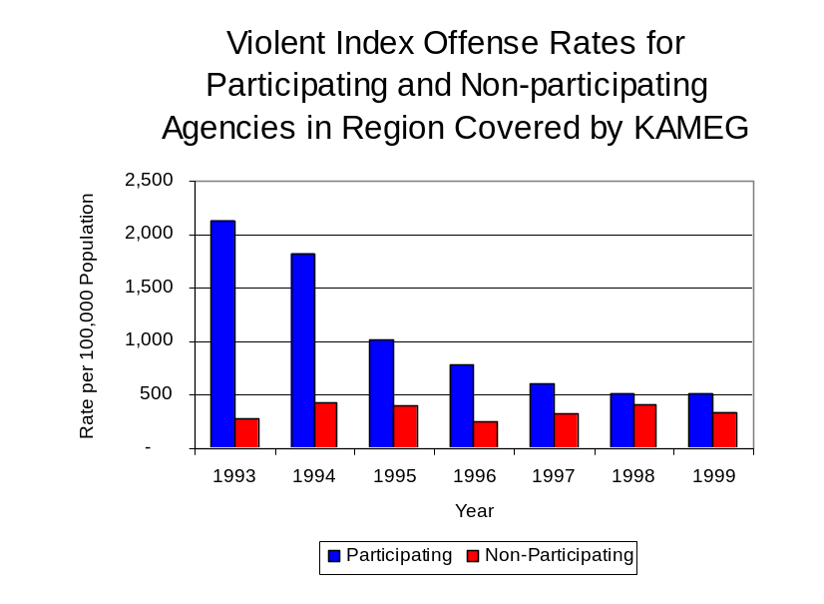
During the period analyzed, the violent Index offense rate for the region covered by KAMEG also decreased 72 percent, from 1,680 offenses per 100,000 population in 1993 to 465 offenses per 100,000 population in 1999. Similarly, the violent Index offense rate in the participating agencies decreased 76 percent, from 2,134 to 509 offenses per 100,000 population, while the rate in the non-participating agencies increased 25 percent, from 275 to 343 offenses per 100,000 population (Figure 1). Thus, while the violent Index offense rate was collectively higher across the jurisdictions that participate in KAMEG than it was among the combined jurisdictions that did not participate in KAMEG, the violent Index offense rate has dramatically decreased during the period analyzed in those agencies that participate in KAMEG, while increasing in those agencies that do not participate in KAMEG, and the difference has become even more dramatic over the past eight years.
Source: ICJIA calculations using
Illinois State Police and U.S. Census Bureau data
Figure 1

Across the 14 individual local law enforcement agencies covered by KAMEG’s jurisdiction, three agencies, the Kankakee Police Department, the Kankakee County Sheriff's Office and the Bradley Police Department, accounted for 87 percent of all violent offenses reported to the police (Figure 2). Nine agencies had fewer than ten violent offenses reported in 1999 and are excluded from Figure 2. When controlling for differences in the populations served by these law enforcement agencies, the violent Index offense rate ranged from 1,138 violent Index offenses per 100,000 population in Hopkins Park to 69 offenses per 100,000 population in Herscher. Five agencies reported no violent Index offenses in 1999.
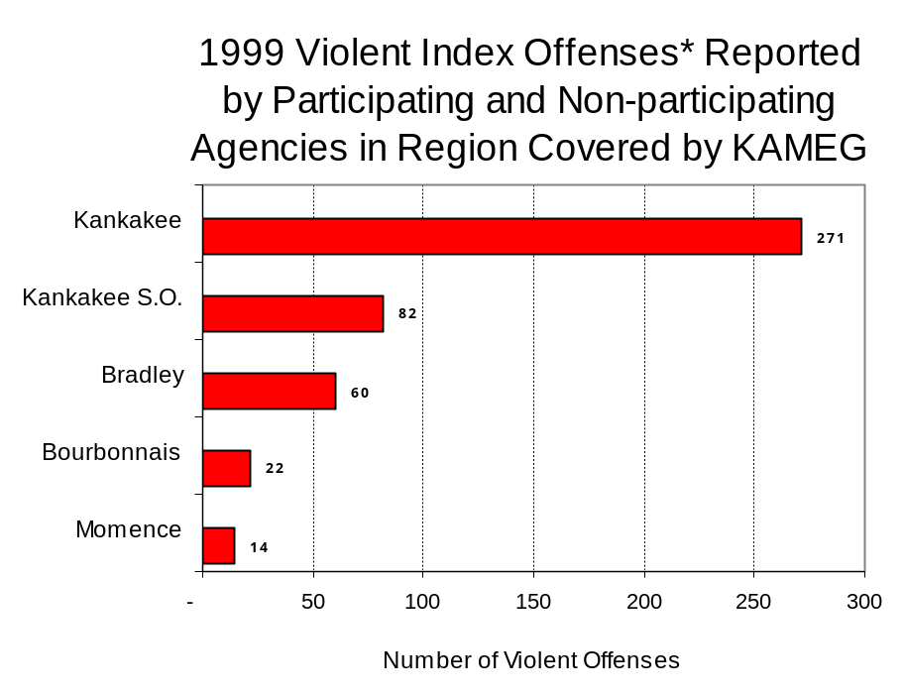
Source: Illinois State Police *Agencies reporting ten or more
violent offenses
Figure 2

An indicator of the workload that law enforcement agencies place on other components of the justice system is the number of arrests made by police, including those for violent and property Index offenses and drug offenses. Unlike offenses, which are what police must respond to, arrests represent those offenders who may eventually be processed through other components of the justice system, including the courts, county jails, and state and local correctional programs.

Between 1993 and 1999, the number of arrests for violent Index offenses made by law enforcement agencies in the region covered by KAMEG decreased 58 percent, from 667 to 281. As with reported violent Index offenses, the majority (79 percent) of violent Index arrests were for aggravated assaults, followed by criminal sexual assaults (14 percent).

During the period analyzed, the violent Index arrest rate for the region covered by KAMEG decreased 59 percent, from 668 offenses per 100,000 population in 1993 to 275 arrests per 100,000 population in 1999. Similarly, the violent Index arrest rate in the participating agencies decreased 67 percent, from 845 to 278 offenses per 100,000 population, while the rate in the non-participating agencies more than doubled, from 119 to 266 offenses per 100,000 population (Figure 3).

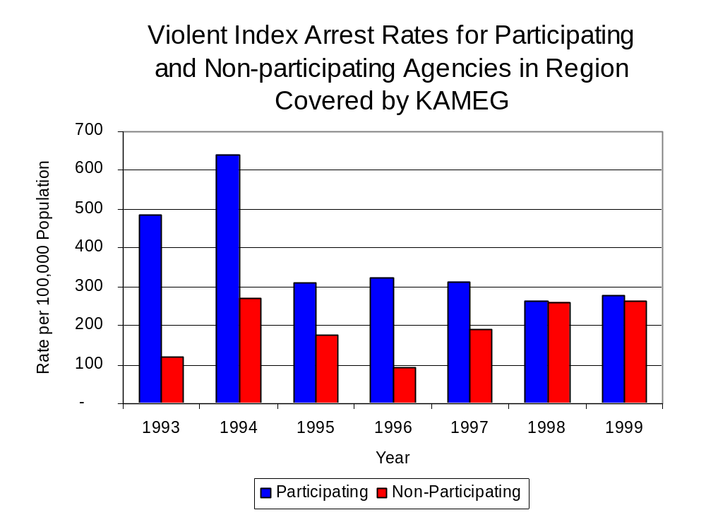
Similar to the number of violent Index offenses, the majority (70 percent) of arrests for violent Index offenses occurring in the region covered by KAMEG were made by three agencies. Eight agencies had fewer than five arrests for violent Index offenses reported in 1999 and are excluded from Figure 4. Of the 281 violent Index arrests made in 1999, the Kankakee Police Department accounted for the largest proportion (35 percent), followed by the Kankakee County Sheriff’s Office (20 percent) and the Bradley Police Department (15 percent) (Figure 4).
Figure 3
Source: ICJIA calculations using
Illinois State Police and U. S. Census Bureau data

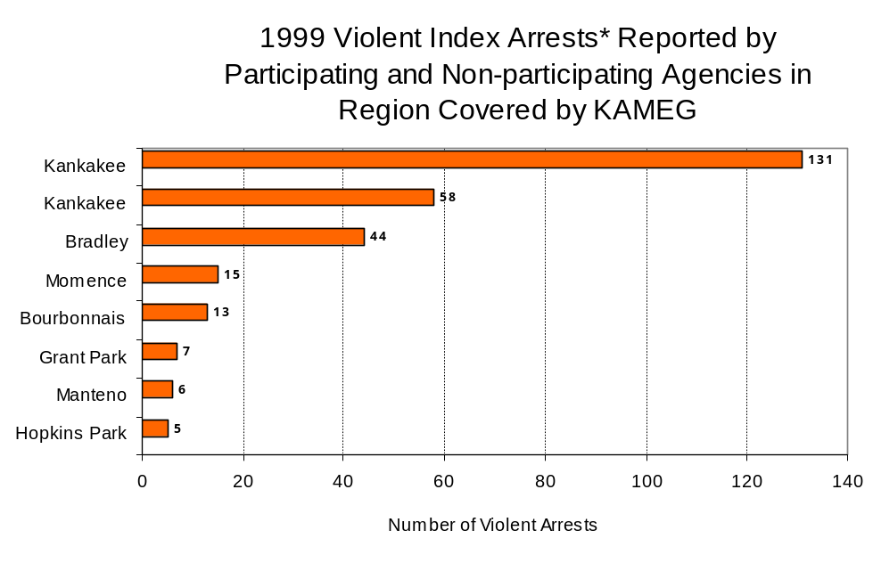
Figure 4
Source: Illinois State Police *Agencies reporting five or
more violent offenses
III. Trends in Drug Arrests

There are two sources of drug arrest data presented in this section. One source is the Illinois Uniform Crime Reporting (I-UCR) program that includes information submitted by local law enforcement agencies on the number of persons arrested for violations of Illinois’ Cannabis Control Act, Controlled Substances Act, Hypodermic Syringes and Needles Act, and Drug Paraphernalia Control Act. In addition, data on drug arrests made by Illinois’ MEGs and task forces are reported to the Illinois Criminal Justice Information Authority. In some jurisdictions, arrests made by the MEG or task force may be reported by both local law enforcement agencies through the I-UCR and to the Authority by the unit. In other jurisdictions, arrests made by the MEG or task force are only reported to the Authority by the unit. Therefore, in some instances drug arrests may be double counted – included in both local agency statistics reported to I-UCR and those of the MEG or task force. Currently there is no mechanism in place to ensure that drug arrest statistics are not being duplicated at both the local agency and MEG/task force level. This should be kept in mind when interpreting the information presented in the following section.

The majority of drug offenses in Illinois are violations of either the Cannabis Control Act – which prohibits the possession, sale and cultivation of marijuana – or the Controlled Substances Act – which prohibits the possession, sale, distribution or manufacture of all other illegal drugs, such as cocaine and opiates. Illinois also has various other laws prohibiting other drug-related activity. These include the Hypodermic Syringes and Needles Act – which prohibits the possession or sale of hypodermic instruments – and the Drug Paraphernalia Control Act – which prohibits the possession, sale or delivery of drug paraphernalia. In general, violations of Illinois Controlled Substances Act are considered to be more serious, since they primarily involve cocaine, heroin, methamphetamine, and hallucinogens, and are almost all classified under Illinois law as felonies. The majority of cannabis and drug paraphernalia offenses encountered by police, on the other hand, tend to be misdemeanor-level offenses.

In 1999, local law enforcement agencies in the region covered by KAMEG reported 991 arrests for drug law violations, 30 percent more than the number in 1993 (761 arrests). Between 1993 and 1999, arrests for violations of Illinois’ Controlled Substances Act consistently out-numbered arrests for violations of the Cannabis Control Act in Kankakee County. During the same period, the number of arrests for violations of the Cannabis Control Act in Kankakee County increased 13 percent, from 269 to 304. Arrests for violations of the Controlled Substances Act decreased 13 percent, from 467 to 405. In addition, arrests for violations of the Drug Paraphernalia Control Act, enacted in 1993, increased dramatically from three in 1993 to 280 in 1999. Much of this increase can be attributed to a 1994 addition to the Drug Paraphernalia Control Act, which included the possession of drug paraphernalia as a violation.

Because arrests for violations of the Drug Paraphernalia Control Act are frequently made in conjunction with other drug offense arrests, these arrests may be double-counted, thus skewing the actual number of drug arrests. Therefore, only arrests for violations of the Cannabis Control Act and Controlled Substances Act will be used for drug arrest comparisons between KAMEG and the participating and non-participating agencies.

During the period analyzed, the drug arrest rate for the Cannabis Control and Controlled Substances Acts, combined, in the region covered by KAMEG decreased 6 percent, from 737 arrests per 100,000 population in 1993 to 693 arrests per 100,000 population in 1999. Similarly, the drug arrest rate in the participating agencies decreased 13 percent, from 947 to 823 arrests per 100,000 population, while the rate in the non-participating agencies nearly quadrupled, from 86 to 332 arrests per 100,000 population. The arrest rate for KAMEG, on the other hand, increased nearly six-fold, from 98 to 672 arrests per 100,000 population (Figure 5). Thus, the drug arrest rate tended to be significantly higher collectively in the jurisdictions that participated in KAMEG than in those jurisdictions that did not participate in KAMEG.
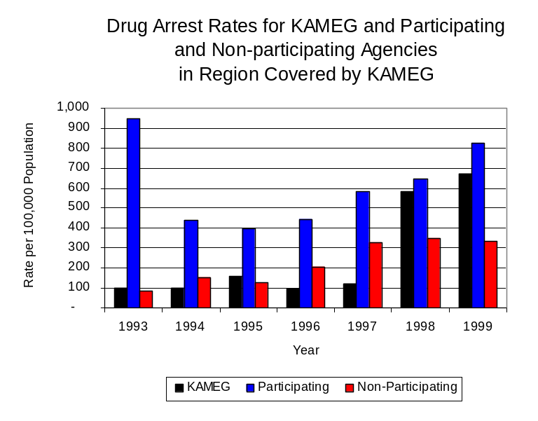
Also, the drug arrest rate achieved by KAMEG was relatively close to that experienced by the participating agencies, meaning that the unit made almost as many arrests for violations of the Cannabis and Controlled Substances Act, with 20 officers, as did all of the participating agencies combined.
Source: ICJIA calculations using Illinois State Police, KAMEG and U.S. Census Bureau data
Figure 5
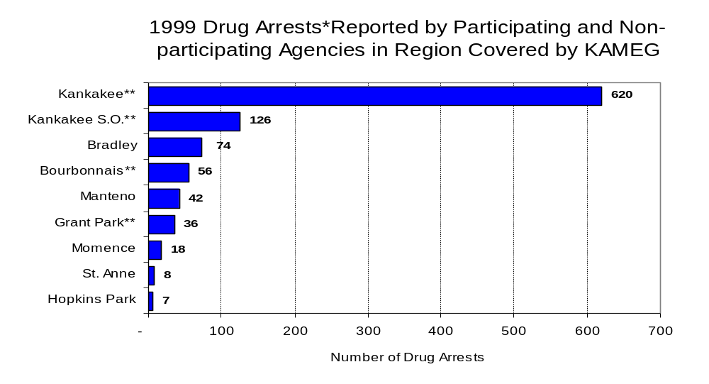
Across the individual local law enforcement agencies in the region covered by KAMEG, the total number of cannabis and controlled substances arrests, ranged from zero to 620 (four agencies reported no drug arrests in 1999). Of the 620 drug arrests made during 1999 in the region, the Kankakee Police Department and the Kankakee County Sheriff's Office accounted for three-quarters of these drug arrests. Eight agencies had fewer than 20 drug arrests reported in 1999 and are excluded from Figure 6. The Kankakee Police Department accounted for the majority (62 percent), while the Kankakee County Sheriff’s Office accounted for 13 percent of the drug arrests made in Kankakee County in 1999 (Figure 6). Among the nine agencies with the highest number of drug arrests during 1999, four participated in KAMEG.
Figure 6
Source: Illinois State Police *Agencies reporting 20 or more drug arrests
**Agencies not participating in KAMEG

In addition to the dramatic difference in the number of drug arrests made, there are also
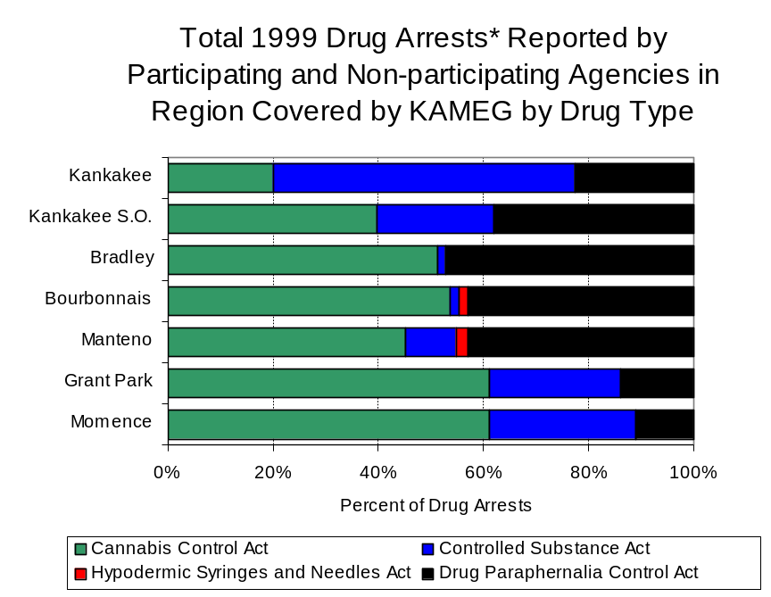
differences in the types of drug law violation arrests across the agencies in the region. In 1999, violations of the Cannabis Control Act accounted for the largest proportion of arrests across most individual agencies in the region covered by KAMEG (Figure 7). However, in the City of Kankakee, which accounted for most arrests in the region, the majority (nearly 60 percent) of arrests in 1999 involved Controlled Substances Act offenses.
Figure 7
Source: Illinois State Police *Agencies reporting 20 or more drug arrests

Although the number of combined cannabis and controlled substances arrests made by KAMEG remained relatively stable between 1989 and 1997, arrests for these offenses increased more than four-fold between 1997 and 1999, to more than 500. In addition, unlike drug arrests made by most local police departments in the region, violations of the Controlled Substances Act accounted for the majority of drug arrests made by KAMEG throughout most of the period analyzed. During the period analyzed, the number of KAMEG arrests for violations of the Cannabis Control Act increased nearly five-fold, from 36 to 206, while arrests for violations of the Controlled Substances Act increased nearly seven-fold, from 38 to 299 (Figure 8).

Between 1993 and 1999, the proportion of drug arrests accounted for by violations of the Controlled Substances Act increased for participating agencies as well as KAMEG, while the proportion accounted for by non-participating agencies decreased. In 1999, 59 percent of the drug arrests made by KAMEG were for violations of the Controlled Substances Act, compared to 51 percent in 1993. Similarly, in 1999, arrests for controlled substances violations accounted for 63 percent of the drug arrests made in the participating agencies, compared to 60 percent in 1993. Conversely, the proportion of Controlled Substances Act violations for the non-participating agencies decreased slightly from 14 percent in 1993 to 13 percent in 1999. Thus, arrests by KAMEG and agencies participating in KAMEG were more likely than arrests by non-participating agencies to involve violations of Illinois’ Controlled Substances Act, as opposed to the Cannabis Control Act. One interpretation of this pattern is that KAMEG and agencies participating in KAMEG were more focused in who they are targeting and arresting than local departments, and are also getting a more serious drug law violator, since violations of the Controlled Substances Act are more likely to involve felony-level offenses.
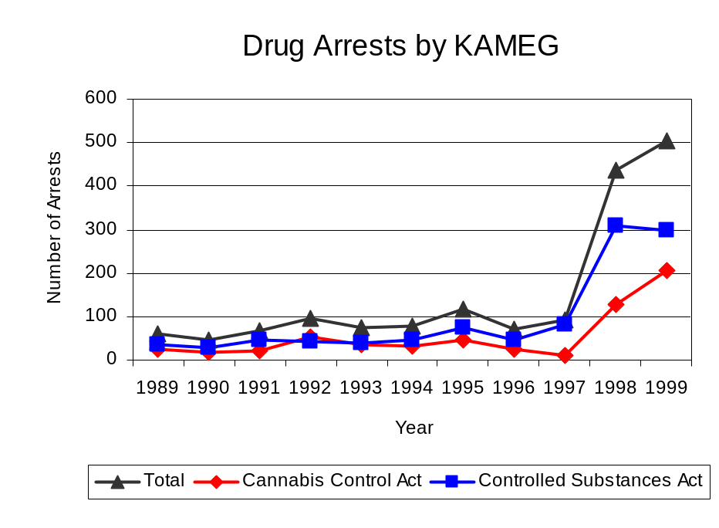
The data presented below represent the percent of total drug arrests made by agencies participating in KAMEG accounted for by KAMEG. An upper and lower bound is shown in Figure 9 which accounts for whether or not the units numbers are counted as part of the UCR submissions made by local departments (which is unknown at this point). The upper bound indicates the percentage of arrests if none of the KAMEG arrests are included in the local UCR submissions. The lower bound indicates the percentage if all of the KAMEG arrests are included in the local UCR submissions. It is estimated that the proportion of all drug arrests across participating agencies accounted for by KAMEG was between 21 to 26 percent in 1993, but increased to between 45 to 82 percent in 1999. Thus, despite the fact that the officers assigned to KAMEG accounted for a small proportion of total officers in the region, they accounted for a relatively large proportion of the drug arrests in the region.
Source: KAMEG
Figure 8
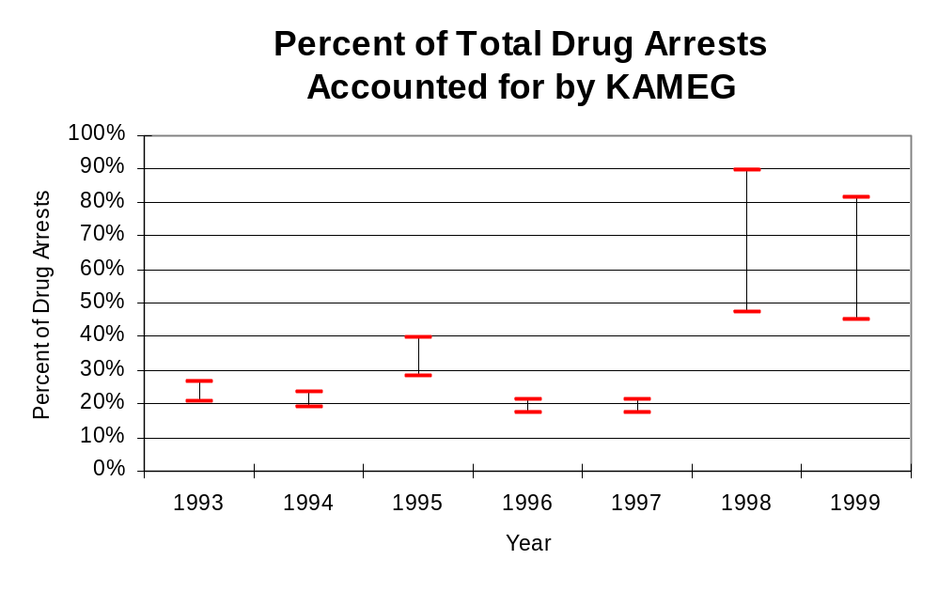
Figure 9

Source: ICJIA calculations using
Illinois State Police and KAMEG data

ce and KAMEG data
The number of arrests for violations of Illinois’ Cannabis Control Act in Kankakee County totaled 304 in 1999, more than double the 130 arrests made for cannabis violations in 1993. Between 1993 and 1999, the proportion of all drug arrests accounted for by violations of the Cannabis Control Act in the region remained unchanged at 43 percent. Agencies participating in KAMEG accounted for the largest portion (87 percent) of the total number of arrests for cannabis violations. KAMEG reported a total of 206 arrests for cannabis violations in 1999, 41 percent of the unit's drug arrests.

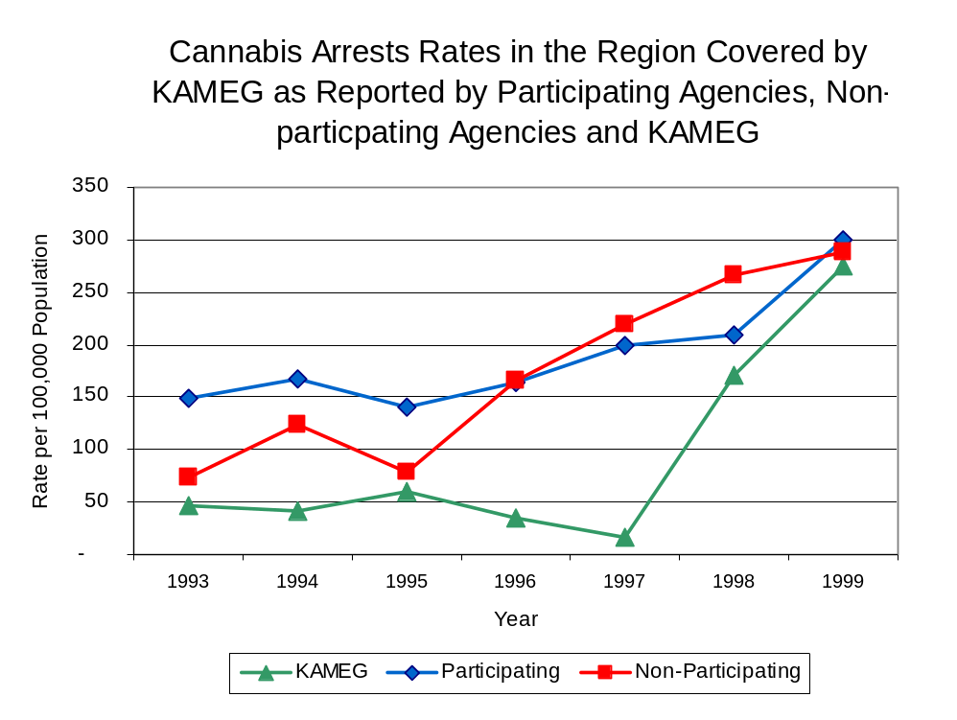
During the period analyzed, the cannabis arrest rate for the region covered by KAMEG more than doubled, from 130 arrests per 100,000 population in 1993 to 297 arrests per 100,000 population in 1999. The cannabis arrest rate in the participating agencies more than doubled, from 148 to 301 arrests per 100,000 population, while the arrest rate in the non-participating agencies more than tripled from 74 to 288 arrests per 100,000 population. The cannabis arrest rate for KAMEG increased nearly five-fold, from 48 to 274 arrests per 100,000 population (Figure 10). Thus, the arrest rate for violations of the Cannabis Control Act was collectively slightly higher in the area served by participating agencies than in the combined jurisdictions of the non-participating agencies.
Source: ICJIA calculations using
Illinois State Police and KAMEG data
Figure 10

The data presented in Figure 11 represent the percent of cannabis arrests made by agencies participating in KAMEG accounted for by KAMEG. An upper and lower bound is shown which accounts for whether or not the unit’s numbers are counted as part of the UCR submissions made by local departments (which is unknown at this point). The upper bound indicates the percentage of arrests if none of the KAMEG arrests are included in the local UCR submissions. The lower bound indicates the percentage if all of the KAMEG arrests are included in the local UCR submissions. It is estimated that the proportion of cannabis arrests across participating agencies accounted for by KAMEG was between 24 to 32 percent in 1993, but increased to between 48 to 91 percent in 1999.

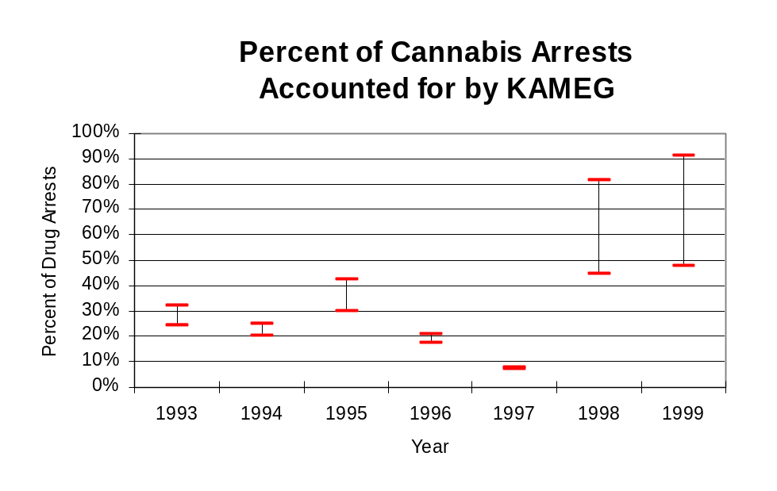
Figure 11
Source: ICJIA calculations using
Illinois State Police and KAMEG data

In Kankakee County, the number of arrests for violations of Illinois’ Controlled Substances Act more than doubled between 1993 and 1999, from 171 to 405. Between 1993 and 1999, the proportion of all drug arrests accounted for by violations of the Controlled Substances Act in the region remained unchanged at 57 percent. In 1999, KAMEG reported 299 arrests for controlled substance violations, 59 percent of all drug arrests reported to the Authority by the unit.

Between 1993 and 1999, the arrest rate for controlled substances act violations for both the region covered by KAMEG and participating agencies more than doubled, from 171 to 396 and 222 to 523 arrests per 100,000 population, respectively (Figure 12). The controlled substances arrest rate in the non-participating agencies more than tripled, from 12 to 44 arrests per 100,000 population. The controlled substances arrest rate for KAMEG increased nearly seven-fold, from 50 to 398 arrests per 100,000 population (Figure 12). Thus, the Controlled Substances Act arrest rate was dramatically higher in the participating agencies than the non-participating agencies.

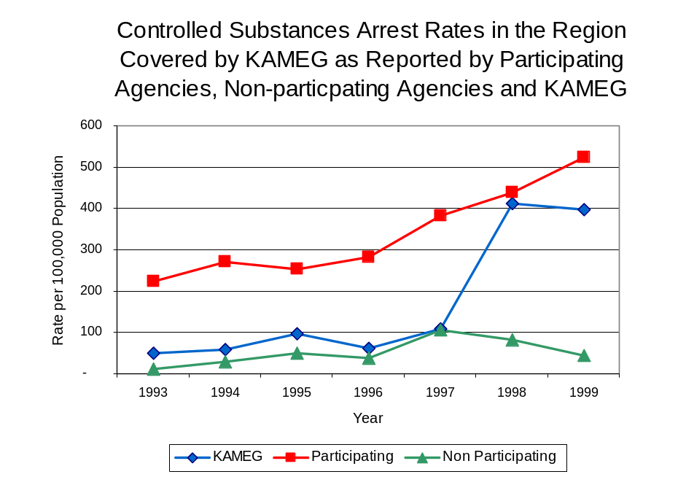
The data presented in Figure 13 represent the percent of controlled substances arrests made by agencies participating in KAMEG accounted for by KAMEG. An upper and lower bound is shown which accounts for whether or not the units numbers are counted as part of the UCR submissions made by local departments (which is unknown at this point). The upper bound indicates the percentage of arrests if none of the KAMEG arrests are included in the local UCR submissions. The lower bound indicates the percentage if all of the KAMEG arrests are included in the local UCR submissions. It is estimated that the proportion of controlled substances arrests across participating agencies accounted for by KAMEG was between 18 to 23 percent in 1993, but increased to between 43 to 76 percent in 1999.
Source: ICJIA calculations using Illinois State Police and KAMEG data
Figure 12
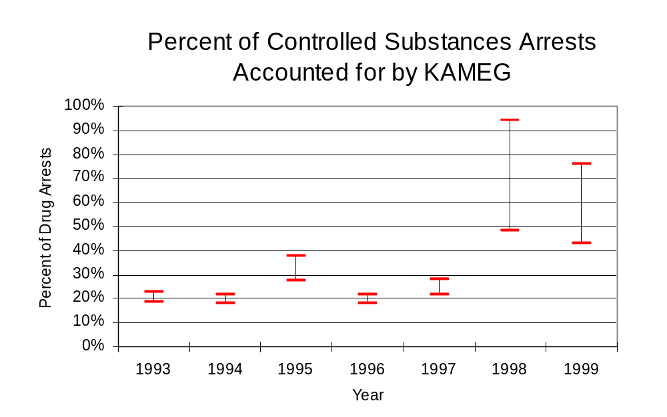
Figure 13
Source: ICJIA calculations using
Illinois State Police and KAMEG data
Nearly one-half of total drug arrests were for delivery although the proportion was higher for offenses involving controlled substances arrests than cannabis arrests. Between 1993 and 1999, the number of drug delivery arrests made by KAMEG increased nearly four-fold, from 61 to 286. Arrests for drug delivery accounted for more than one-half (60 percent) of all drug arrests made by KAMEG between 1993 and 1999. When cannabis and controlled substance arrests were examined separately, during the period analyzed, arrests for delivery of controlled substances accounted for 77 percent of the total number of arrests made for violations of the Controlled Substance Act, whereas, arrests for the delivery of cannabis accounted for 57 percent of all arrests for violations of the Cannabis Act. While the number cannabis and controlled substance arrests increased, the proportion of delivery arrests decreased. The proportion of delivery arrests involving controlled substances decreased from 89 percent in 1993 to 77 percent in 1999. Similarly, the proportion of arrests for delivery of cannabis decreased significantly, from 75 percent to 27 percent between 1993 and 1999.
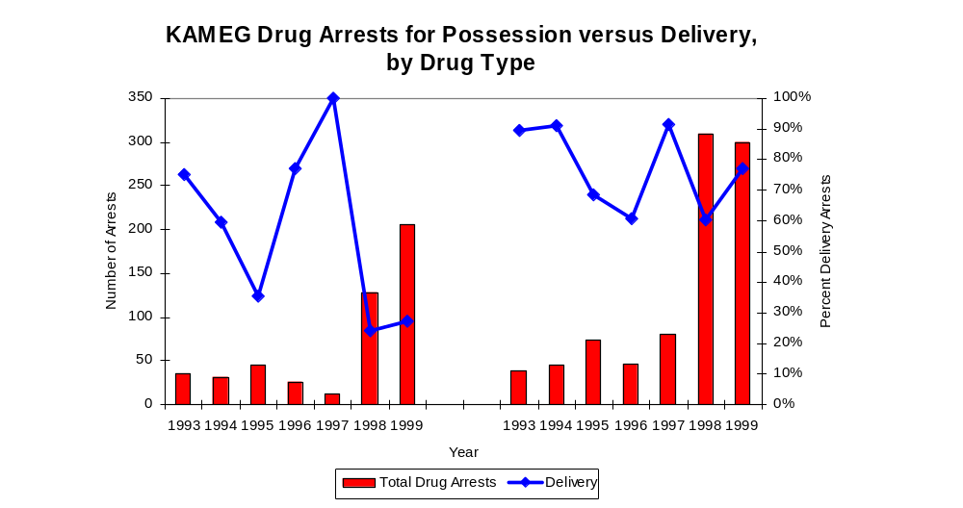
Figure 14
Source: ICJIA calculations using KAMEG data
Cannabis Control Act

Controlled Substances Act

IV. Trends in Drug Seizures

Drugs seized by law enforcement agencies are another indicator of the extent and nature of illegal drug trade in a jurisdiction. When illegal drugs are seized by law enforcement agencies, all or a portion of the total amount seized is submitted to a crime lab for analysis. Most agencies submit drugs to one of the Illinois State Police crime labs. These labs record the quantity of drugs submitted from each county. This section discusses trends in the quantities of illegal drugs seized and submitted to the Illinois State Police from local law enforcement agencies in Kankakee County as well as the quantities of drugs seized by KAMEG. It is important to note, however, that while KAMEG data report the total quantities of drugs actually seized, local agency data only represent the quantities of seized drugs that are submitted to the Illinois State Police for analysis.

As in most Illinois jurisdictions, cannabis accounts for the majority of illegal drugs seized in the region covered by KAMEG. The quantity of cannabis seized and submitted by law enforcement agencies in Kankakee County increased 12 percent, from 16,119 grams in 1993 to 17,989 grams in 1999. However, the quantity of cannabis seized by KAMEG decreased 85 percent between 1993 and 1999, from 90,382 grams to 13,139 grams despite jumping to more than two million grams seized in 1995 (Figure 15). In 1999, KAMEG's cannabis seizure rate of 119,651 grams per 100,000 population was slightly lower than the seizure rate of 17,582 grams per 100,000 population in the region covered by KAMEG (Map 2).
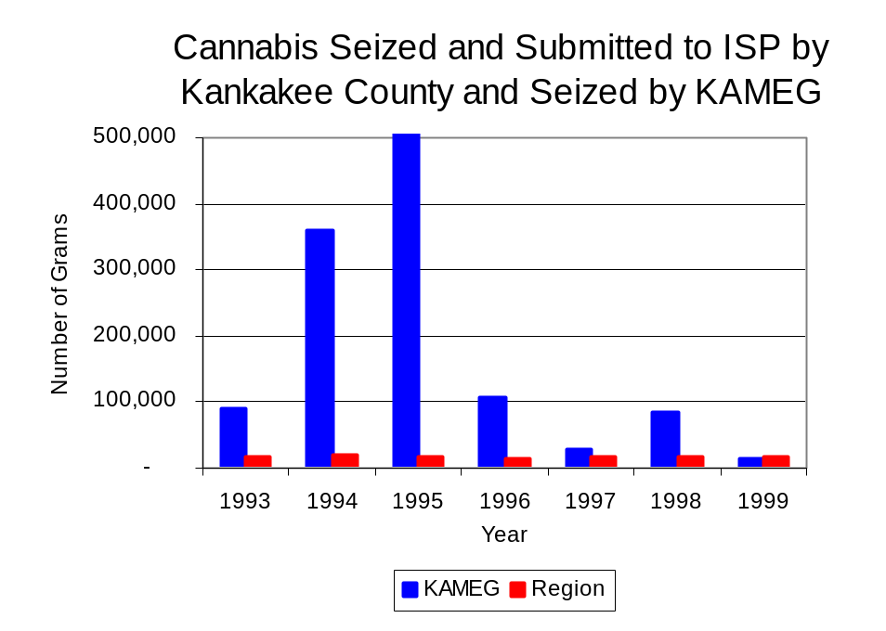
Figure 15
Source: Illinois State Police and KAMEG
Between 1993 and 1999, a combination of crack and powder cocaine has accounted for a small proportion of drugs seized in the region covered by KAMEG. However, the quantity of cocaine seized and submitted by law enforcement agencies in Kankakee County decreased 41 percent, from 1,198 grams in 1993 to 708 grams in 1999. Between 1993 and 1999, the quantity of cocaine seized by KAMEG nearly doubled, from 683 grams to 1,360 grams.

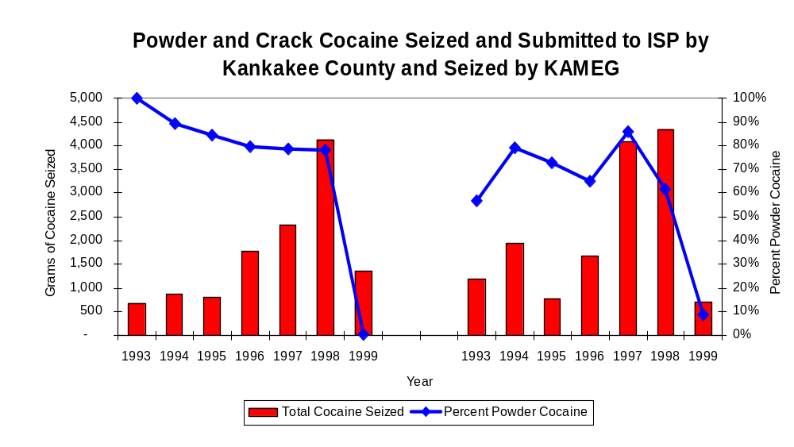
Despite this increase, the proportion of all cocaine seized by KAMEG and local agencies in Kankakee County accounted for by powder cocaine has decreased dramatically between 1993 and 1999. The proportion of all cocaine seized accounted for by powder cocaine in the region covered by KAMEG decreased from 57 percent in 1993 to 9 percent in 1999. Similarly, for KAMEG, although powder cocaine accounted for the largest proportion of total cocaine seizures between 1993 and 1998, the proportion decreased from 100 percent in 1993 to less than 1 percent (0.3) in 1999--indicating a growing presence of crack cocaine in the region (Figure 16). In 1999, KAMEG's cocaine seizure rate of 1,808 grams per 100,000 population was more than triple the cocaine seizure rate of 692 grams per 100,000 population in the region covered by KAMEG (Map 3).
KAMEG
Region
Figure 16
Source: Illinois State Police and KAMEG

The total quantity of illegal drugs seized and submitted by law enforcement agencies in Kankakee County increased 8 percent between 1993 and 1999, from 17,347 grams to 18,739 grams. On the other hand, the total quantity of illegal drugs seized by KAMEG has decreased 84 percent, from 95,920 grams in 1993 to 15,127 grams in 1999.

During the period, methamphetamine seizures accounted for a relatively small proportion of total drugs seized by enforcement agencies in Kankakee County, accounting for less than four grams seized during the entire seven year period analyzed. Between 1993 and 1999, there were no reported methamphetamine seizures by KAMEG. In 1999, neither KAMEG nor Kankakee County reported methamphetamine seizures, while the statewide methamphetamine seizure rate was 98 grams per 100,000 population (Map 4).

Trends in Prosecutions for Drug Offenses and All Felonies

Although Illinois has one of the best court reporting systems in the country, the Administrative Office of the Illinois Court only collects information regarding the aggregate number of court filings. Currently, there are no statewide data available on court filings by offense type. The Administrative Office of the Illinois Courts reports data on felony criminal court cases. After screening a case and deciding it warrants further action, the state’s attorney must file formal charges in court. Felony cases can be punished by a probation term up to four years and incarceration for more than one year.

Between 1989 and 1999, the number of felony filings in the region covered by KAMEG increased 3 percent, from 776 to 797 (Figure 17).

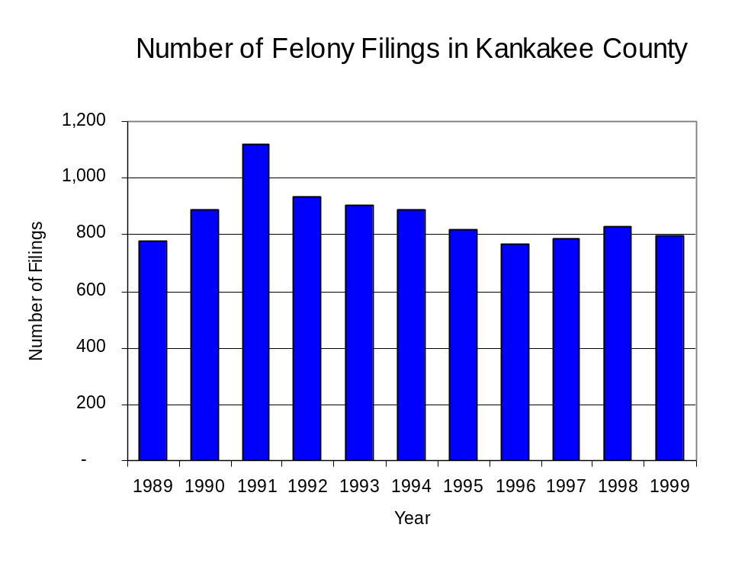
Figure 17
Source: Administrative Office of the Illinois Courts

Between 1989 and 1999, there were a total of 1,734 drug prosecutions initiated as a result of KAMEG arrests in Kankakee County. During this time, the number of KAMEG drug arrests increased more than seven-fold, from 61 arrests in 1989 to 505 arrests in 1999 (Figure 18). The majority (66 percent) of KAMEG drug offender prosecutions during this period were for violations of the Controlled Substance Act. In some years, the proportion of arrests resulting in a prosecution exceeded 100 percent. This is due to some slight differences in the timing of an arrest and the filings of charges, or could be due to charges, rather than defendants, being reported by the unit. In addition, some offenders have charges filed, and a subsequent warrant issued, without an arrest taking place.

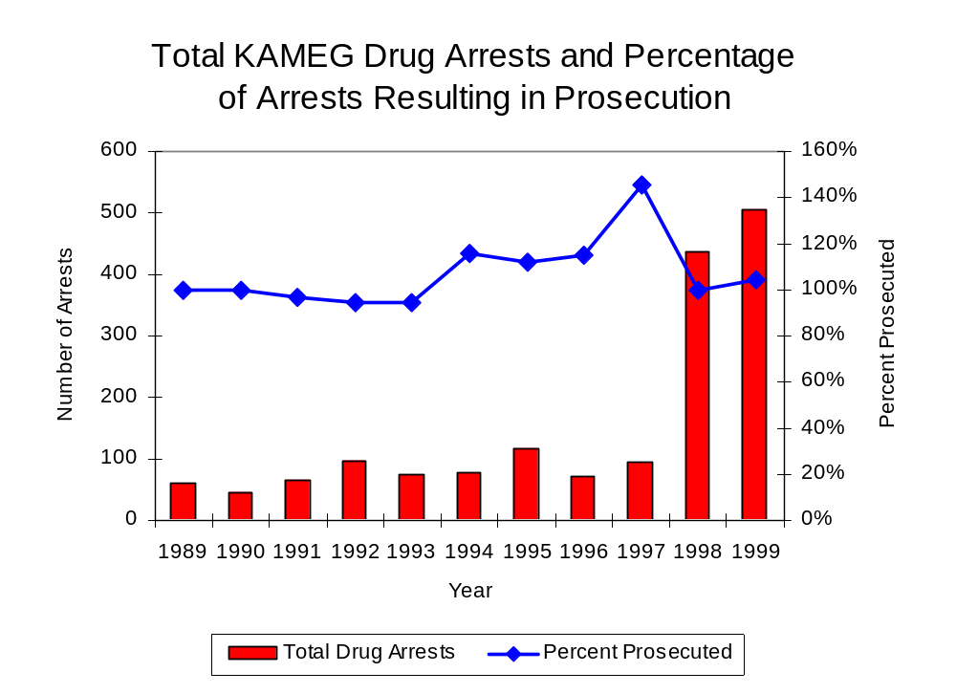
Figure 18
Source: KAMEG

Between 1989 and 1999, less than one-half (47 percent, or 820) of the 1,734 drug offenders who were prosecuted as a result of KAMEG activity were convicted. Convictions for controlled substances accounted for two-thirds of all KAMEG initiated convictions during the period analyzed.

VI. Trends in Percent of Convicted Drug Offenders Sentenced to Prison

Anyone convicted of a felony in Illinois can be sentenced either to prison or probation, or receive conditional discharge. A number of factors influence the type and length of sentence imposed on convicted felons, including the severity of the crime, the offender’s criminal and social history, safety of the community and legislation affecting certain types of offenses. For some types of convictions, a sentence to prison is required by state statute.

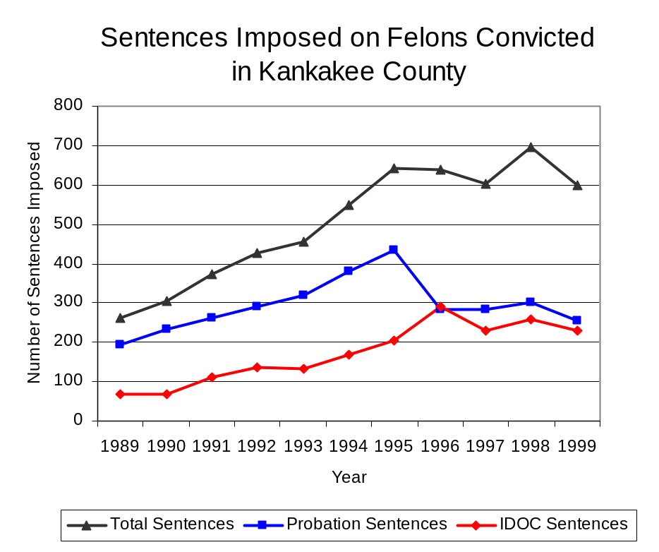
Between 1989 and 1999, the number of offenders convicted of a felony and sentenced in the region covered by KAMEG more than doubled, from 263 to 598. The number of convicted felons sentenced to the Illinois Department of Corrections (IDOC) more than tripled between 1989 and 1999, from 69 to 230, while the number of convicted felons sentenced to probation increased 31 percent, from 194 to 254. As a result, the proportion of felons sentenced to IDOC increased from 26 percent to 38 percent of total felony sentences, while the proportion of felons sentenced to probation decreased from 74 percent in 1989 to 42 percent in 1999 (Figure 19). Sentences other than prison or probation accounted for the remaining 20 percent of felony sentences imposed in 1999.
Figure 19
Source: Administrative Office of the Illinois Courts

Between 1989 and 1999, the number of KAMEG drug offenders convicted and sentenced increased nearly five-fold, from 24 to 141. During the period analyzed, the number of convicted KAMEG drug offenders sentenced to either prison or jail increased more than five-fold, from eight to 49 and from four to 26, respectively. The number of convicted KAMEG drug offenders sentenced to probation increased nearly five-fold, from 12 to 66 during the same period (Figure 20). In 1999, among those KAMEG drug offenders convicted and sentenced, probation sentences accounted for the largest proportion (47 percent), followed by prison sentences (35 percent) and jail sentences (18 percent).
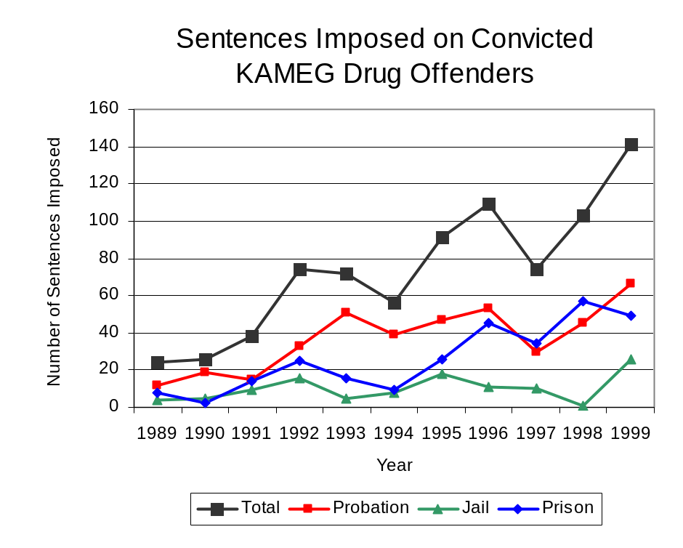
Figure 20
Source: KAMEG

Between state fiscal years 1989 and 1999, the number of new court commitments to IDOC’s Adult Division for drug offenses from the region covered by KAMEG increased nearly 12-fold, from six to 77. The number of drug offender admissions by KAMEG also increased from eight to 70 between 1989 and 1999 (Figure 21). Thus, during the period analyzed, prison sentences resulting from KAMEG cases accounted for majority (86 percent) of all drug-law violators sentenced to prison from the region where KAMEG operates.
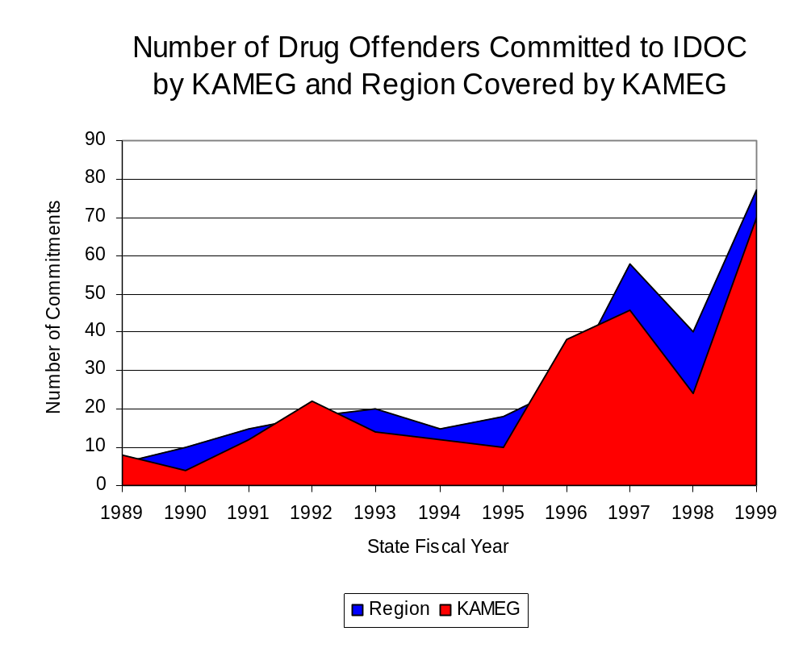
Figure 21
Source: Illinois Department of Corrections and KAMEG

During the period analyzed, drug offenders accounted for an increasing proportion of adults convicted and sentenced to prison from Kankakee County. In 1989, drug offenses accounted for 9 percent of all commitments to IDOC, compared to 39 percent in 1999 (Figure 22).
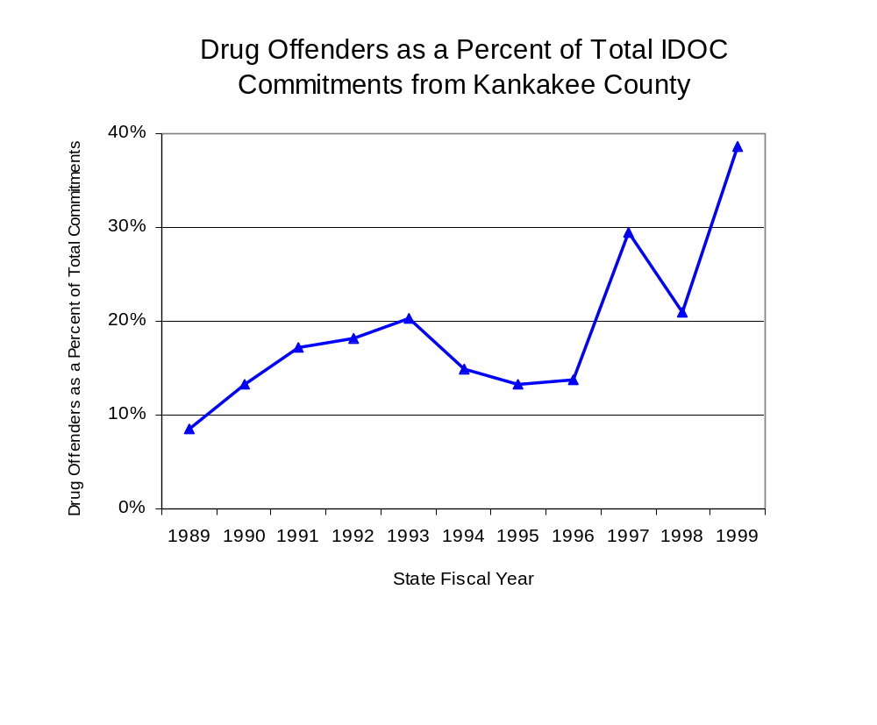
Figure 22
Source: Illinois Department of Corrections

Penalties for drug offenses were also examined between 1993 and 1999. Class 1 felonies accounted for the largest proportion (48 percent) of sentences to IDOC for drug offenses, followed by Class 4 felonies (26 percent), Class 2 felonies (13 percent), Class X felonies (11 percent) and Class 3 felonies (2 percent). Between 1993 and 1999, the number of Class 1 felony sentences increased more than six-fold, from six to 45, while Class 4 felony sentences more than quadrupled, from three to 13 and Class X felony sentences increased more than four-fold, from three to 15. The number of Class 2 and Class 3 felonies increased slightly, from one to two and from zero to two, respectively, during the period analyzed (Figure 23).

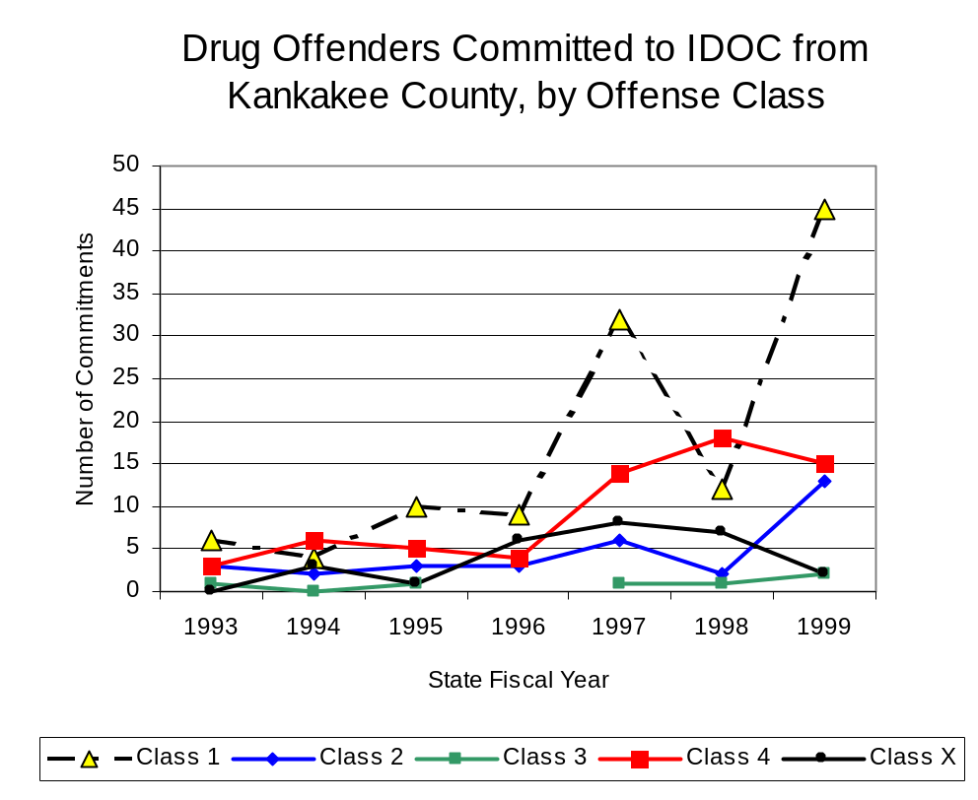
Figure 23
Source: Illinois Department of Corrections

Despite the dramatic increase in Class 1 felony sentences to IDOC between 1993 and 1999, the mean sentence length for Class 1 felonies decreased during the period, from 6.7 to five years. On the other hand, the mean sentence length for Class 4 felonies increased 31 percent, from 1.3 to 1.7 years, while the mean sentence for a Class 2 felony increased 19 percent, from 3.7 to 4.4 years, and Class 3 sentence lengths increased 17 percent, from three to 3.5 years. While there were no Class X felony sentences from Kankakee County reported in 1993, the mean sentence length for Class X felonies decreased 34 percent, during the period analyzed, from 10.3 to 6.8 years.

VII. Trends in Drug Treatment Admissions in KAMEG Region by Drug Type

In addition to considering indicators of the extent and nature of drug abuse as reported through the criminal justice system (for example, arrests and prison sentences), there are indicators of substance abuse available from other Illinois social service agencies. Overseeing and supporting treatment for substance users, whether they are referred from the criminal justice system or elsewhere, is the responsibility of the Illinois Department of Human Services’ Office of Alcoholism and Substance Abuse (OASA). It is important to note, however, that while OASA data represent the majority of the overall demand for substance abuse treatment in the state, some private programs provide treatment services to a smaller but significant number of clients who may not be included in the state’s reporting system.

In state fiscal year 1999, OASA reported 1,003 admissions for alcohol or drug abuse treatment from Kankakee County, more than double the 444 admissions in 1989 (Figure 24). Among the 1,003 admissions to substance abuse treatment in state fiscal year 1999, 30 percent (303) reported alcohol as their primary substance of abuse, while abuse of illicit substances accounted for 64 percent and 6 percent reported no primary substance of abuse.

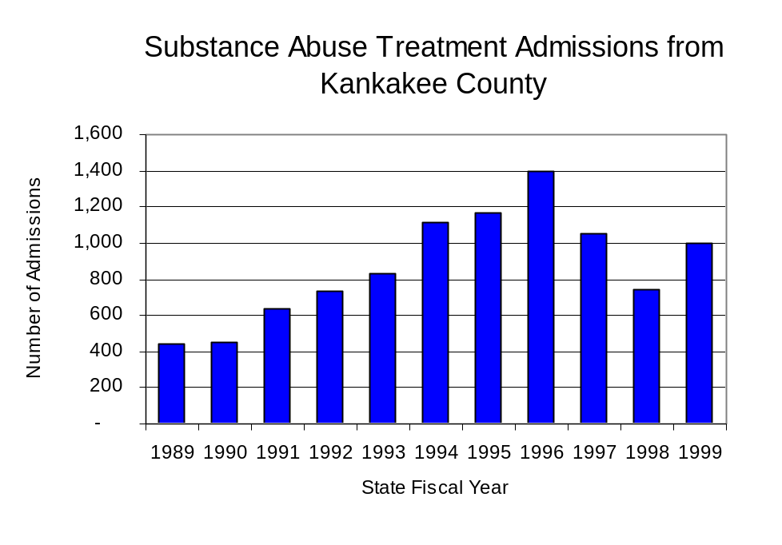
Figure 24
Source: Illinois Department of Human Services’
Office of Alcoholism and Substance Abuse
While drug treatment admissions can be considered a measure of the demand placed on a specific component of the human services system within Illinois, the extent and nature of drug treatment admissions could also be indicative of the substance abuse problem within a particular region. In some respects, the characteristics of those admitted to drug treatment can be considered a profile of the most serious drug abusers in the community, since admission to treatment requires a documented, formal assessment of a drug problem and a level of substance abuse warranting treatment. By comparing the types of drugs of abuse reported by those admitted to substance abuse treatment with the types of drugs involved in law enforcement agency arrests, one can get a sense of the degree to which arrests reflect the drugs which are most problematic within a community.

In the following analyses, the percent of arrests accounted for by drugs classified under Illinois’ Controlled Substances Act (primarily cocaine, heroin, and methamphetamine) versus the Cannabis Control Act (marijuana) across the participating agencies combined, non-participating agencies combined and KAMEG are compared to the proportion of drug treatment admissions accounted for by these groups of substances. From these comparisons, a number of general conclusions can be made. First, the proportion of arrests made by KAMEG and those participating in KAMEG accounted for by drugs other than marijuana (Controlled Substances Act offenses) was very close to the proportion of drug treatment admissions from the covered region accounted for by these substances. Thus, there is considerable convergence between the drugs involved in KAMEG arrests and treatment admissions. On the other hand, the majority of arrests by local police departments (including non-participating agencies) were for cannabis offenses. Thus, while local arrests may reflect the most widely available and used drug in the region, they tend not to involve the substances considered to be most serious (i.e., felony versus misdemeanor) nor the substances individuals are seeking and receiving treatment for (Figure 25).

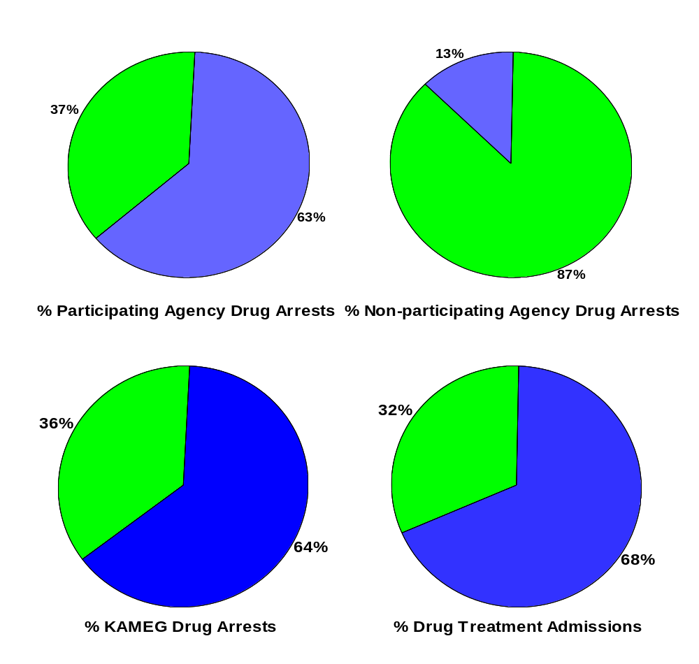
CannabisControlled Substances
Source: ICJIA calculations using Illinois Department of Human Service's Office of Alcoholism and Substance Abuse and KAMEG data
Comparison of Drug Arrests by KAMEG and Participating and
Non-participating Agencies vs. Drug Abuse Treatment Admissions in Kankakee County, 1999
Figure 25

VIII. Trends in Drug Exposed Births

Illinois continues to experience the effects of prenatal substance abuse. In Illinois, if a baby is born and thought to have been exposed to illegal substances or alcohol, either through observation by physicians or toxicology tests, the case is reported to the Illinois Department of Children and Family Services. These cases are then investigated by DCFS to verify the child’s prenatal exposure to either alcohol or illegal substances. Between state fiscal years 1989 and 1999, nearly one-half (50) of Illinois’ 102 counties reported at least one case of a substance-affected infant.

Between state fiscal years 1989 and 1995, the number of drug-exposed infant cases reported in the region covered by KAMEG soared from eight to a period high of 27, before decreasing almost every year since to a period low of two cases in 1999. Between state fiscal years 1989 and 1999, 127 cases, or 86 percent of all cases reported, were verified as involving prenatal drug use by a DCFS investigation. Mirroring the trend of reported cases, verified cases of drug-exposed infants in the KAMEG region also jumped dramatically between 1989 and 1995 from five to 22 before dropping to two cases in 1999 (Figure 26).
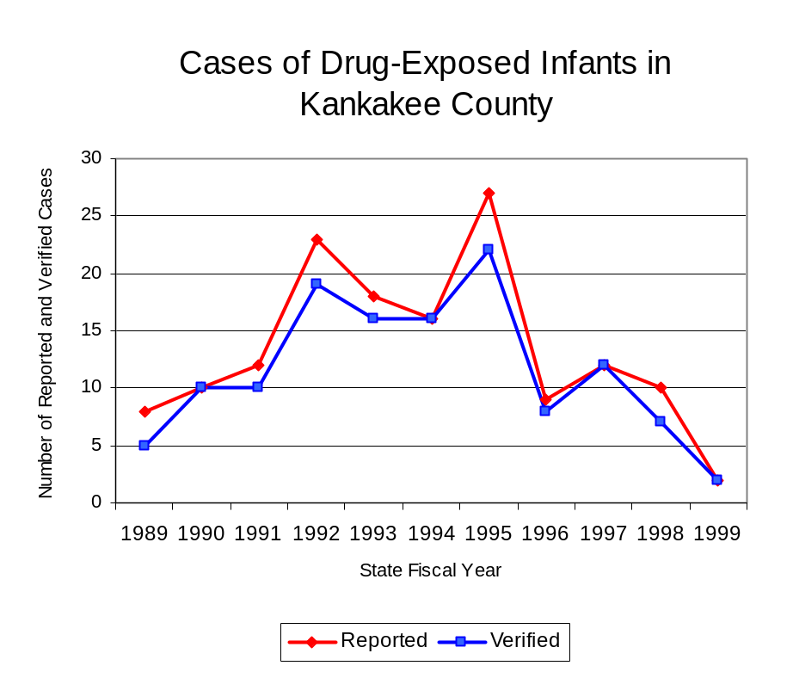
Source: Department of Children and Family Services
Figure 26

Summary of Drug Situation

Although the distribution of illegal drugs is difficult to measure precisely, data obtained from criminal justice sources can be helpful in estimating drug availability. Information from a recent survey of Illinois drug enforcement units, as well as the most up-to-date data available on drug price, are presented as indicators of the drug supply in Illinois.

In 1995, 1996 and 1998, the Authority conducted a survey of each MEG and task force in Illinois to gauge the perceived availability of drugs in the areas they cover. Questions were asked concerning the availability of specific drugs, and results were analyzed by region of the state. MEGs and task forces are classified as being either urban, rural or mixed urban/rural based upon the classification of the county(s) that each unit covers, and, for purposes of this report, are compared to the average of similar units.

According to KAMEG survey responses, cannabis, cocaine and crack continued to be the most visible drugs on the street and were all reported to be “readily available” across all regions analyzed. The perceived availability of most drugs has increased in mixed urban/rural regions similar to KAMEG and across Illinois since the 1996 survey, while perceived availability of for all drug types either remained unchanged or decreased slightly in the region covered by KAMEG. The perceived availability LSD has decreased slightly in all regions since the 1996 survey. Methamphetamine was reported as moderately available across Illinois and by all MEGs and task forces in mixed urban/rural regions but available to a somewhat lesser degree in the region covered by KAMEG. (Figure 27).
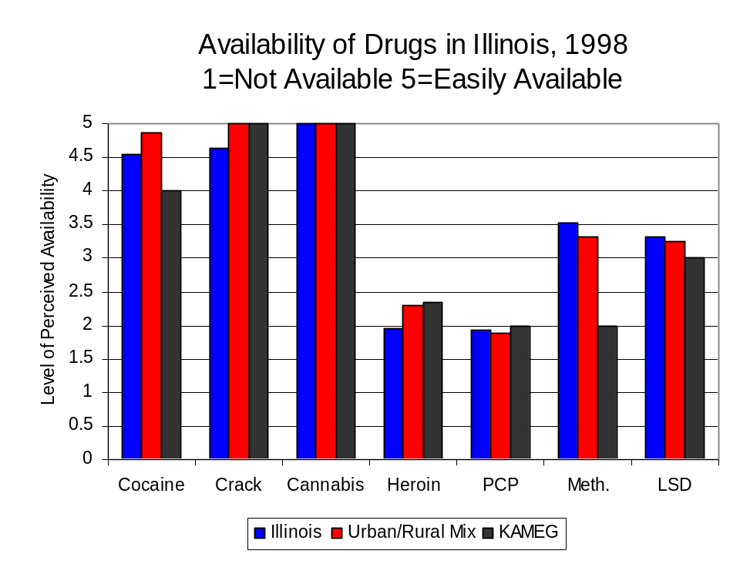
Figure 27
Source: Authority Survey of Illinois MEGs and task forces
Another market indicator that can be used to assess availability is drug price. Lower prices tend to suggest a sufficient supply to meet demand, while increasing prices indicate decreased availability.

Based on a statewide survey of MEG and task force units, the average price of cocaine, and crack appear to be relatively stable across all regions surveyed in 1998, while prices for PCP and heroin appear to vary somewhat across Illinois. The average price of cocaine increased across all regions between 1996 and 1998, while the average price for heroin increased in the region covered by KAMEG and decreased in the other mixed urban/rural regions. Between 1996 and 1998 the average price of PCP dropped dramatically across Illinois and all other MEGs and task forces in mixed urban/rural regions, from $73 to $43 and from $100 to $5, respectively. The 1998 average price of cocaine reported by KAMEG was $100 per gram, compared to $98 per gram across Illinois and $103 per gram reported by all MEGs and task forces in other mixed urban/rural regions (Figure 28). On the other hand, the average price of heroin in the region covered by KAMEG was reported as $300 per gram, significantly higher than the price of $165 per gram across Illinois and the price of $214 per gram reported by all other MEGs and task forces in mixed urban/rural regions. In 1998, the average price of cannabis was reported as approximately $5 per gram in the KAMEG region, $7 per gram in primarily mixed urban/rural regions and $8 per gram across Illinois.

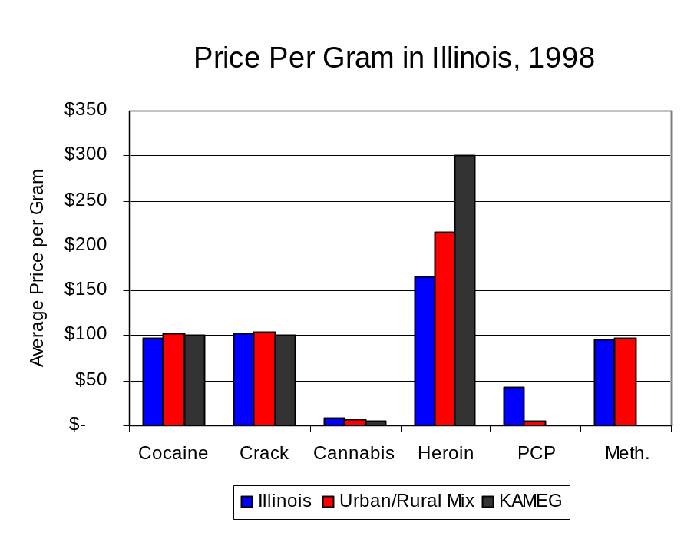
Figure 28
Source: Authority Survey of Illinois MEGs and task forces

X. Appendices
1999 Percent of Illinois'
County-level Population Covered by an Authority-funded Multi-jurisdictional Enforcement Group or Task Force
Map 1
* Shaded counties indicate that at least one law enforcement agency within the county participates in a MEG or task force
Percent of County Population Covered by MEG or Task Force

1999 Illinois
Cannabis
Seizure Rates, by County
Map 2
Cannabis Seizure Rate
(rate per 100,000 population)
1999 Illinois
Cocaine
Seizure Rates, by County
Map 3
Cocaine Seizure Rate
(rate per 100,000 population)
1999 Illinois Methamphetamine
Seizure Rates, by County
Map 4
Methamphetamine Seizure Rate
(rate per 100,000 population)

Bibliography

Administrative Office of the Illinois Courts, Annual Report to the Supreme Court of Illinois.
1989 through 1999 reports, Springfield, Illinois.

Administrative Office of the Illinois Courts’ Probation Division, Statewide Probation Data
Report. 1989 through 1999 reports, Springfield, Illinois.

Illinois Department of Human Services’ Office of Alcoholism and Substance Abuse. Data
provided for state fiscal years 1989 through 1999, Springfield, Illinois.

Illinois Department of Children and Family Services, Child Abuse/Neglect Statistics Report,
1989 through 1999 reports, Springfield, Illinois.

Illinois Department of Corrections. Data provided for state fiscal years 1989 through 1999,
Springfield, Illinois.

Illinois State Police, Crime in Illinois. 1993 through 1999 reports, Springfield, Illinois.

Illinois State Police, Drug Statistics Report. Monthly reports, January 1989 through
December 1999, Springfield, Illinois.

Kankakee Area Metropolitan Enforcement Group. Monthly reports, January 1989 through
December 1999, Bourbonnais, Illinois.

U.S. Bureau of the Census.


George H. Ryan, Governor
Peter B. Bensinger, Chairman
Candice M. Kane, Executive Director

